Margaret Morenike Ayodele

Implementation Assignment

A sequence diagram to add lab to the database

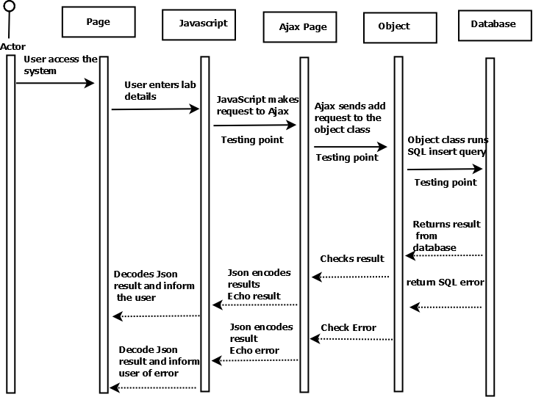

Specification for Requirement

|  |  |
| --- | --- |
| User Requirement | The user wants to create instances of new physical locations for labs |
| Specific User | Administrator |
| Functional Requirement | The user shall be able to add new lab information and send to the database |
| Function Name | addLab() |
| Description | This function adds new physical locations of labs |
| User Interface | This shall be a web application. Hence, a user enters all the necessary  information of a lab in a web form and submits these to a  database on the server |
| Constraints | Only administrators can add a lab to the database. Administrators that add a particular lab has the right to issue permissions to other users to edit the added labs. |

|  |  |  |
| --- | --- | --- |
| Unit Test point | Testing | Result |
| SQL statement to add lab | Write SQL statement with test inputs and run it using phpMyAdmin.  Test input: LabId, LabName, LabLocation, LabCapacity  Expected Result: a new lab details should be added to the database | A dialogue box notification to show success upon a successful addition to the database |
| addLab method in Lab class | Write a code to create object of the class and call the method with test inputs and compare output in database Test input: LabId, LabName, LabLocation, LabCapacity  Expected Result: Notification of successful save or error (if saving failed) | Display formatted lab information to user |
| addLab method in Lab class | Write a PHP unit test to test the code  Input: LabId, LabName, LabLocation, LabCapacity  Output:it returns number of assertions if there are no errors  Assert Condition: it returns true or false | The result displays the assertion of the code after it tests, whether it was successful or not (with errors) |

Professional Testing

<?php

/**

*@Author : Margaret Morenike Ayodele

*@Date: 17th March, 2016

*@Assignment: WebTechnoloy Implementation Assignment

*@category Inventory Management

*@package Test Laboratories

*/

require ('labs.php');

/* The name of the class*/

class labsTest extends PHPUnit_Framework_TestCase

{

public function setUp()

{

$lab = new Labs();

}

/**

*@method boolean testaddLab() allows an admin to add labs

*by their names, id and physical locations

*@param String $lab_name// The name of a lab

*@param integer $lab_id// The assigned id of a lab

*@param varchar $lab_location// The assigned location of a lab

*@param integer $capacity// The equipment capacity of a lab

*@return $this->assertsEquals()//this returns true or false

**/

public function testaddLab()

{

$lab = new Labs();

$result = $lab->add_lab("Physics lab", 208, "Engineering block", 100,

"EN0048", "SN0087");

$this->assertEquals(true, $result);

}

}

?>

